Why does Linux use per-thread kernel stacks?
As Sebas Sujeen has put it quite nicely, the kernel needs a private stack for each process to do whatever work is asked for by the process (e.g. writing to a terminal, opening a file, reading a device, etc). This has to be done separately for each process in order not to corrupt the memory space of other processes. When a process traps into kernel mode through a system call, the kernel saves all the information needed to go back to user mode when the system call finishes. This information includes general and special register values, user mode stack pointer (SP), instruction pointer (IP) for the next instruction in the process code segment, and possibly other info. Some of these are pushed automatically by the processor when it encounters a trap to kernel mode, others are manually pushed by the kernel.
When a clock interrupt happens and the scheduler decides to switch processes, it reads the values it needs to resume the next process from that process’s kernel stack frame. Now if the kernel was to use a global stack it would be corrupted by interleaving process information. It would also mean the kernel will eventually run out of stack space (usually a limited amount) as the stack grows in an enormous amount by repeated pushing of process register values.

The kernel stack is used to hold the context of the process that the kernel should return to, and when the kernel executes on behalf of the process (system calls), the kernel uses the kernel mode stack of the process/thread. The immediate thing that comes to my mind is kernel pre-emption . Say the kernel is executing a system call and a timer interrupt arrives, the scheduler detects that the currently executing user space process has finished its time quantum and therefore preempts it when it is executing in kernel space. So the next time the process gets rescheduled, it has to execute from where it left off, if it shares the kernel stack with any other process, then that process could corrupt its stack. Another subtle point is that, for SMP processors, linux supports runqueue balancing ie if the number of processes running on a particular core is much greater than the number of processes in other cores, the scheduler moves some of the tasks from one core's run queue to the other, in this case, if you don't have a per thread/task kernel stack, you might lose the context.

Embedded OS

Contiki Hybrid OS

→ monolithic + micro-kernel
→ Event driven kernel (task consume the full cpu time)
→ Supports Preemptive multi-threading (implemented as an application library). Optionally linked with the program, if program needs multi-threading.

→ Concurrency can be achieved without per thread stacks or locking mechanisms.
→ No Hardware Abstraction Layer (HAL) in Contiki. Hence device drivers communicates directly with the hardware.

Pros and Cons of HAL

Advantages
→ It is possible to switch to another hardware such as switching to another micro-controller if needed.
→ It allows cross-development.
→ Continuous Integration with automated unit tests as we do in jenkins.

Disadvantages
→ Cannot fully utilize the all available features of the attached hardware such as micro-controller. Limits functionalities of hardware.

CPU multiplexing is provided by the core system.

Main Components of the contiki system
→ Consists of kernel, libraries and applications/services.
→ It is possible to dynamically replace the processes at runtime.
→ All processes shared the same address space and all run in same protection domain.
→ A process can run in either
→ Cooperative -------------- Runs Sequentially in a queue. (1st has right to use the CPU )
→ Preemptive ------------- Higher priority task have right to use CPU.

Contiki system partitioned into two parts.
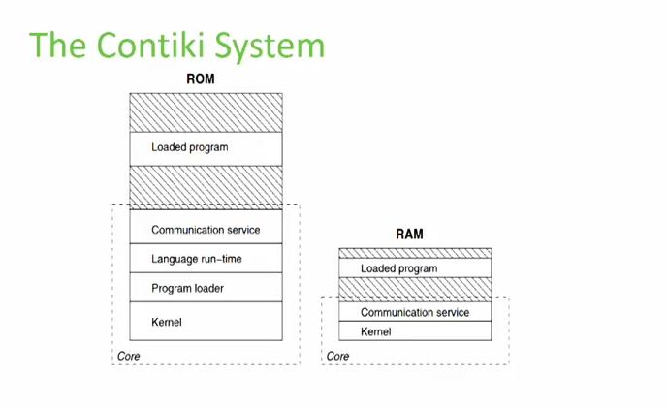

Kinds of Events

Asynchronous Vs Synchronous
→ Async events are not delivered immediately after they have been posted.
→ They stored in an event queue; delivered to the receiving process by the kernel.
→ The receiver might be a specific process or all running processes. If 1 pass directly to that process, if multiple then pass 1 by 1 sequentially.

→Sync event delivered immediately.
→ Single specific receiver.

Difference between Services and Libraries

What is communication in Contiki
Communication in wireless sensor network architecture includes three parts.
→ Sensor Nodes
→ Gateway
→ Backend Systems

Two Communication Stacks in Contiki
→ uIP – a small RFC compliant TCP/IP stack.
→ Rime – Light weight communication stack designed for low power radios.

RIME
→ Simple protocols can be used by complex ones.
→ Single Hop, multi-hop permitives.

Proto-threads
→ implementation of simple flow of control in a simple way.
→ Light weight and stack-less threads.
→

